W311R (W311R+)-How to limit the computer to access some websites by URL filter function (R)?
Product line: wireless Question category: function configuration

Q：Why we need to configure the URL Filtering?
A：In order to control the computer have access to websites. You can use URL Filtering to allow the computer to have access to certain websites at fixed time and forbids it having access to certain websites at fixed time.

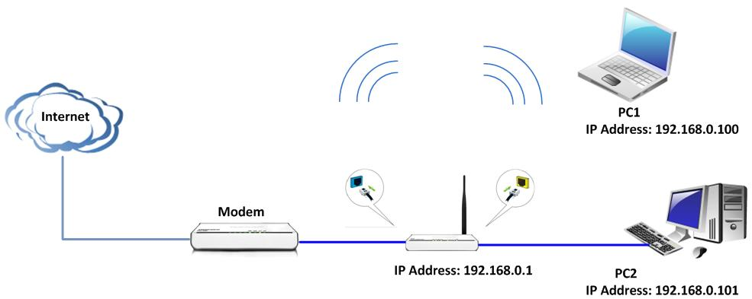

Steps are following:
- Login the management page of the router.
- Click the Security Settings→URL Filter on the left of the page.
Tick Enable for the URL Filtering Settings
For example, you want to block the computers whose IP Address is 192.168.80.100 - 192.168.80.200 to access the websites that include “google” from 8:00 am to 18:00 pm every day. And the computers with other IP Address can access the website. You can set the router following the picture as below.

